ZX-UX C48 SDK
USER MANUAL
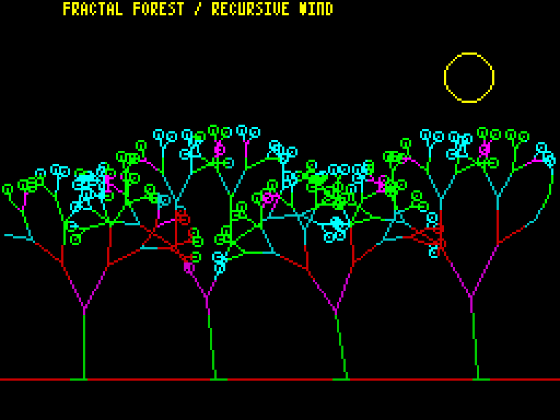
Portable C48 compiler and development runtime
for the Sinclair ZX Spectrum 48K programming model
Supratim Sanyal / SANYALnet Labs
https://supratim-sanyal.blogspot.com/
SDK 1.0.0 | September 2026
Copyright (c) 2026 Supratim Sanyal of SANYALnet Labs.
See the repository root LICENSE for licensing terms.

1. About This SDK
ZX-UX C48 SDK is the portable host-side development kit for writing, compiling, testing, and running C48 programs on modern Windows, Linux, and macOS systems while the target-native ZX-UX toolchain continues to evolve. This manual describes the 1.0.0 final-release candidate; the formal 1.0.0 GitHub release is not published until the release gates pass.
This manual is intentionally short. It covers installation and SDK-specific workflow. It does not redefine the C48 language and it does not replace the detailed compiler manual.
C48 language authority: C48 Language Specification Rev 0.11.docx - use this for syntax, types, conversions, expressions, storage, function semantics, and other language rules.
Compiler detail: ZX-UX C48 Compiler User Manual Rev 0.11.docx - use this for the detailed compiler interface, diagnostics, and compiler behavior.
Host-development boundary. The SDK compiles to the deterministic C48B1 host executable format and executes it in the C48 virtual machine. C48B1 is not Z80 machine code, ZX-UX OBJ1, or ZX-UX MEX1. The host API in usr/src/c48host.h is also a development profile, not a claim that the final native ZX-UX ABI is frozen. Windows-specific portability wording in the frozen Compiler User Manual describes the target/native compatibility contract; it is not the host-SDK platform support matrix.

2. Installation
- Python 3.10 or newer.
- Windows: Python available as python on PATH.
- Linux/macOS (POSIX): Python available as python3 on PATH.
- Tkinter is needed only for the graphical display window.
- No third-party Python packages are required by the compiler or non-audio headless runtime. Audible beep() playback requires the optional playsound3==3.3.2 adapter. Automated release evidence proves ROM-derived waveform and blocking timing numerically/headlessly; it does not certify that a physical speaker emitted sound. The release package is one platform-neutral ZIP containing both Windows batch and POSIX shell launchers; no separate native host installer is required.
Clone the repository:
git clone https://github.com/tuklusan/zx-ux-c48-sdk-sinclair-zx-spectrum-48k-unix-c-compiler-software-development-kit.git
cd zx-ux-c48-sdk-sinclair-zx-spectrum-48k-unix-c-compiler-software-development-kit
Quick verification:
Windows:
c48.bat --version
c48run.bat --version
Linux / macOS (POSIX):
./c48 --version
./c48run --version
Full repository gate:
python -B compiler/verify_release.py

3. SDK Usage
The SDK workflow is compile, then run. Sources under usr/src/ compile by default into the matching path under usr/bin/. Sources elsewhere compile beside the source with a .c48b suffix unless an output path is supplied.
Task | Example | Purpose
Compile | c48 usr/src/demos/forest.c | Build the C48B1 host executable.
Run graphically | c48run usr/bin/demos/forest.c48b | Open the Tk visualizer and run interactively.
Run headless | c48run --headless usr/bin/demos/forest.c48b | Execute without a GUI.
Dump screen | c48run --headless --dump-screen forest.scr usr/bin/demos/forest.c48b | Write the exact 6912-byte Spectrum screen.
Select font | c48run --font PATH usr/bin/demos/forest.c48b | Use another valid F4X8 font resource.
Host heap | c48run --heap 2048 usr/bin/demos/forest.c48b | Change host-development heap ceiling.
Execution budget | c48run --max-steps 10000 usr/bin/demos/forest.c48b | Bound VM execution for tests or hostile input.
Runtime notes. The host runtime models the native Spectrum 256x192 bitmap/attribute screen. Shift+Space acts as BREAK while a graphical program is running; after the program returns, the same chord closes the held final frame. The default host heap ceiling is 1024 bytes; --heap accepts even values from 0 through 8192. --max-steps 0 leaves normal execution unlimited.
For the full compiler option set, diagnostics, and detailed compiler behavior, see ZX-UX C48 Compiler User Manual Rev 0.11.docx.

4. Worked Example - Fractal Forest
Source: usr/src/demos/forest.c. This shipped graphics demo draws recursive trees, animates wind by changing branch angle, and uses the SDK demo API for Spectrum graphics.
Windows:
c48.bat usr\src\demos\forest.c
c48run.bat usr\bin\demos\forest.c48b
Linux / macOS (POSIX):
./c48 usr/src/demos/forest.c
./c48run usr/bin/demos/forest.c48b
Deterministic headless screen capture:
./c48run --headless --dump-screen forest.scr usr/bin/demos/forest.c48b

Authoritative shipped source:
// ============================================================
// Copyright (c) 2026 Supratim Sanyal of SANYALnet Labs.
// Proprietary rights reserved except as licensed in LICENSE.
//
// ZX-UX C48 SDK - SANYALnet Labs Non-Commercial License.
// Non-commercial use permitted; Commercial Use and AI/ML
// model training prohibited unless separately authorized.
//
// Attribution required: Based on original work by Supratim
// Sanyal of SANYALnet Labs. See root LICENSE for full terms.
// ============================================================
#include "demoapi.h"
void branch(int x, int y, int len, int ang, int dep)
{
int nx;
int ny;
if (dep <= 0 || len < 3) return;
nx = x + d_cos(ang) * len / 128;
ny = y + d_sin(ang) * len / 128;
if (!d_ok(nx, ny)) return;
ink(2 + (dep & 3));
bright(dep < 3);
draw(x, y, nx, ny);
if (dep == 1) {
ink(4 + ((x + y) & 1));
circle(nx, ny, 2);
return;
}
branch(nx, ny, len * 3 / 4, ang + 18, dep - 1);
branch(nx, ny, len * 3 / 4, ang - 22, dep - 1);
}
void scene(int f)
{
int i;
int x;
int sway;
cls();
paper(0);
ink(2);
bright(0);
draw(0, 18, 255, 18);
for (i = 0; i < 4; i++) {
x = 38 + i * 60;
sway = d_sin(f * 6 + i * 31) / 18;
branch(x, 18, 32 + (i & 1) * 6,
64 + sway, 6);
}
ink(6);
bright(1);
circle(214, 156, 11);
print_at(0, 7, "FRACTAL FOREST / RECURSIVE WIND");
}
int main(int argc, char **argv)
{
int f;
int n;
n = d_frames(argc, argv, 12);
for (f = 0; f < n; f++) {
scene(f);
yield();
}
return 0;
}

Appendix A. Specifications and Features
Specification / Feature | Current SDK behavior
SDK version | 1.0.0 (final candidate; formal release pending desktop certification)
Host platforms | Windows, Linux and macOS command-line workflow; Tk graphical visualizer for interactive use
Implementation | Python-based C48 compiler and 16-bit C48 virtual machine
Compiler output | Deterministic C48B1 host executable; separate from native ZX-UX object/executable formats
Integer model | char 1 byte; short 2 bytes; int 2 bytes; pointer 2 bytes; plain char unsigned
Float storage | 5-byte Spectrum-style float representation with deterministic core arithmetic support
Logical address space | 64 KiB C48 address space with 16-bit pointers
Display model | 256x192 Spectrum display; exact 6912-byte screen state = 6144 bitmap + 768 attributes
Text | 64x24 software text using packed 4x8 F4X8 font resources
Graphics | INK, PAPER, BRIGHT, FLASH, OVER, INVERSE, plotting, drawing, circles, UDG support
Execution modes | Graphical Tk frontend or deterministic headless execution; optional exact screen dump
Heap | 1024-byte default host ceiling; --heap supports even values 0..8192
Safety controls | --max-steps VM execution budget and capped C48 function-call depth
Verification | Full verifier on Ubuntu x64, Windows x64, macOS arm64 and macOS Intel under Python 3.10/3.13; deterministic rebuilds, manifest validation, security fixtures
Shipped demonstrations | 21 graphics demos with independent CI runner assignments, plus a 14-game corpus
Python dependencies | No third-party packages for compiler/non-audio runtime; audible beep() optionally uses playsound3==3.3.2

Documentation References
Language: C48 Language Specification Rev 0.11.docx - authoritative C48 language definition.
Compiler: ZX-UX C48 Compiler User Manual Rev 0.11.docx - detailed compiler usage and behavior.
Project repository: https://github.com/tuklusan/zx-ux-c48-sdk-sinclair-zx-spectrum-48k-unix-c-compiler-software-development-kit
Author / SANYALnet Labs blog: https://supratim-sanyal.blogspot.com/

